Caring for Your Future
A CONFERENCE FOR HEALTH and SOCIAL CARE SUPPORT WORKERS


Thursday 19th February 2015
at Conwy Business Centre.
9.30am to 4.30pm
Refreshments & Lunch included.
CPD Certificate issued for full day attendance.
Contact/Return Booking form to: Anita Curley, 48,Cader Ave, Kinmel Bay, Conwy LL18 5HY
OR email sylvia.curley@homecall.co.uk

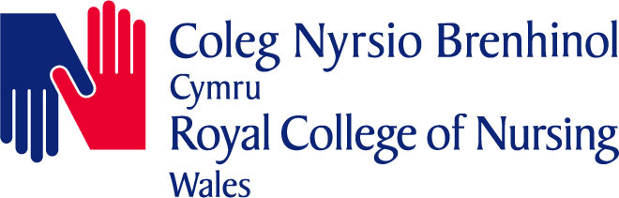

NORTH WALES BRANCH

“CARING FOR YOUR FUTURE”
NORTH WALES HEALTH & SOCIAL CARE SUPPORT WORKER CONFERENCE
Conwy Business Centre
Thursday 19th February 2015

Please book one place for me on this Conference as follows:

NAME.......................................................................................................................……..…
(Mr/Mrs/Miss/Ms)

HOME ADDRESS..................................................................................................………...

.................................................................………...Postcode...................................…………
PLACE OF WORK:................................................................................................………………..…….

JOB TITLE:………………………………………………………………….………………..

DAYTIME TEL No:..........................….……………………………………………………..

E-MAIL ADDRESS:…………………………………………………………..………………

Any special dietary requirements:......................................................................………..…..

Any other special requirements………………………………………………………………

THE CLOSING DATE FOR RECEIPT OF ALL APPLICATIONS IS
12th February 2015

Please return booking form to:
Anita Curley, 48,Cader Ave, Kinmel Bay Conwy. LL185HY
(All Places are issued on a “first come, first served basis”)
Once your application form has been received you will receive a letter/ email of confirmation in respect of your place, when further details will then be sent to you by 12th February 2015

THIS CONFERENCE IS FUNDED BY THE NORTH WALES BRANCH OF THE RCN

